**translation from Hebrew to English- panel B502**

**Words appear on LCD**

|  |  |
| --- | --- |
| דלת נפתחת! | the door is open! |
| סיסמה: | Password: |
| סיסמת מנהל  סיסמה: | Admin password password: |
| דירה: | Apartment: |
| שגיאה! | Error! |
| שגיאת כרטיס! | Card error! |
| מצלצל: | Calling: |
| שגיאת דירה! | apartment error! |

first page

Welcome!

To call -

Enter apartment

number + 

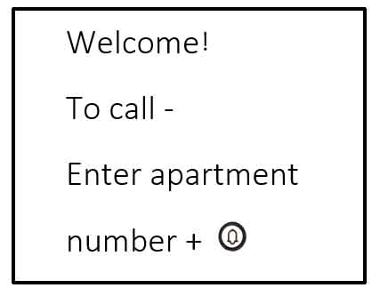

second –page

To cancel press 

select a name

from the list

press  

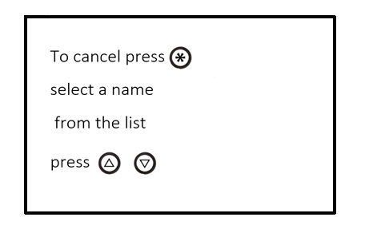

Third page

To call, press 

To unlock,press 

+ 4 Digits code

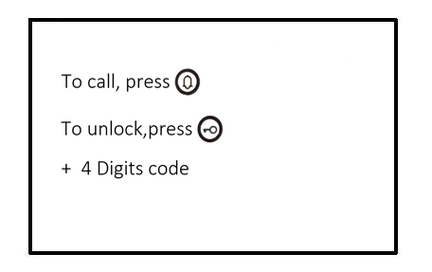

Down on the **Third** page (**signal** mode)

high signal

Medium signal

low signal

no signal

SIM not exist

Active SIM

Inactive SIM

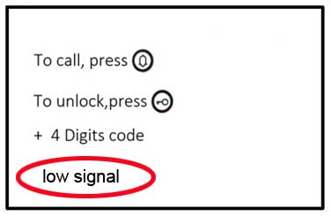

Settings menu

System settings

1-13 

Menu 1

1- Add / Edit user

2- Delete user

3- Delete all users

Total:

Sub-item 1.1

apartment:

Name:

Tel 1:

Tel 2:

Tel 3:

Confirm Save?

Save!

Error!

Sub-item 1.2

Apartment:

Name:

Confirm

Deletion?

Delete!

Sub-item 1.3

Delete all

Users?

Deleted!

Menu 2-

1- Add a password

2-delete password

3- Delete all

Total:

Sub-item 2.1

:Room

Password:

Confirm:

Confirm Save?

Save!

Error!

Sub-item 2.2

: Room

Confirm

Deletion?

Delete!

Sub-item 2.3

Delete all

Passwords?

Deleted!

Menu 3-

Add a card

Delete card

Delete all cards

Total:

Sub-item 3.1

:Room

Card:

Confirm Save?

Save!

Error!

Sub-item 3.2

:Room

Confirm

Deletion?

Delete!

Sub-item 3.3

Delete all

cards?

Deleted!

Menu 4-

Talk time:

Save!

Menu 5-

Call panel:

On

Off

Save!

Menu 6-

Ring time:

Save!

Menu 7-

Voice

Instructions:

On

Off

Save!

Menu 8-

Relay time:

Save!

Menu 9-

CMD Door

Open 1:

Save!

Menu 10-

CMD Door

Open 2:

Save!

Menu 11-

Camera:

On

Off

Save!

Menu 12-

Admin password:

Password: X X X X X X

Confirm

Password: X X X X X X

Confirm Save!

Save!

Error!

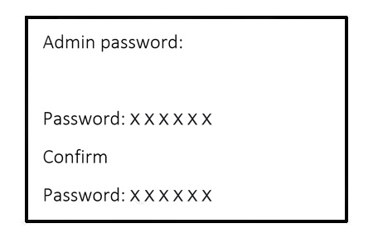

Menu 13-

Speech volume:

Save!